Configure an Application Load Balancer with Autoscaling
experimentLabschedule1 houruniversal_currency_altNo costshow_chartIntroductory
infoThis lab may incorporate AI tools to support your learning.

Overview
Application Load Balancing (HTTP/HTTPS) is implemented at the edge of Google's network in Google's points of presence (POP) around the world. User traffic directed to an Application Load Balancer (HTTP/HTTPS) enters the POP closest to the user and is then load-balanced over Google's global network to the closest backend that has sufficient available capacity.
In this lab, you configure an Application Load Balancer (HTTP) as shown in the diagram below. Then, you stress test the load balancer to demonstrate global load balancing and autoscaling.
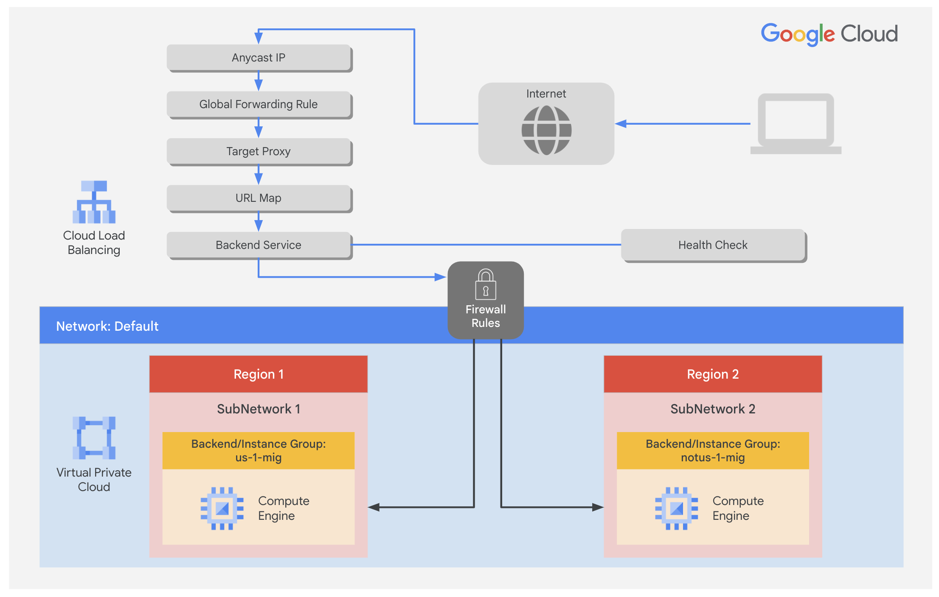

Objectives
In this lab, you learn how to perform the following tasks:
- Create a health check firewall rule
- Create a NAT configuration using Cloud Router
- Create a custom image for a web server
- Create an instance template based on the custom image
- Create two managed instance groups
- Configure an Application Load Balancer (HTTP) with IPv4 and IPv6
- Stress test an Application Load Balancer (HTTP)
For each lab, you get a new Google Cloud project and set of resources for a fixed time at no cost.
- Click the Start Lab button. If you need to pay for the lab, a pop-up opens for you to select your payment method. On the left is the Lab Details panel with the following:
  - The Open Google Cloud console button
  - Time remaining
  - The temporary credentials that you must use for this lab
  - Other information, if needed, to step through this lab
- Click Open Google Cloud console (or right-click and select Open Link in Incognito Window if you are running the Chrome browser).
The lab spins up resources, and then opens another tab that shows the Sign in page.
Tip: Arrange the tabs in separate windows, side-by-side.
- Note: If you see the Choose an account dialog, click Use Another Account.
- If necessary, copy the Username below and paste it into the Sign in dialog.
- "Username"
- Copied!
- You can also find the Username in the Lab Details panel.
- Click Next.
- Copy the Password below and paste it into the Welcome dialog.
- "Password"
- Copied!
- You can also find the Password in the Lab Details panel.
- Click Next.
- Important: You must use the credentials the lab provides you. Do not use your Google Cloud account credentials.
- Note: Using your own Google Cloud account for this lab may incur extra charges.
- Click through the subsequent pages:
  - Accept the terms and conditions.
  - Do not add recovery options or two-factor authentication (because this is a temporary account).
  - Do not sign up for free trials.
After a few moments, the Google Cloud console opens in this tab.
Note: To view a menu with a list of Google Cloud products and services, click the Navigation menu at the top-left, or type the service or product name in the Search field. 

Task 1. Configure a health check firewall rule
In this task, you configure a firewall rule to allow health check traffic to your instances.
Health checks determine which instances of a Application Load Balancer (HTTP) can receive new connections. The health check probes to your load-balanced instances come from addresses in the ranges 130.211.0.0/22 and 35.191.0.0/16. Your firewall rules must allow these connections.

Create the health check rule
Create a firewall rule to allow health checks.
- In the Google Cloud console, in the Navigation menu (), click VPC network > Firewall.
Notice the existing ICMP, internal, RDP, and SSH firewall rules.
Each Google Cloud project starts with the default network and these firewall rules.
- Click Create Firewall Rule.
- Specify the following, and leave the remaining settings as their defaults:
Property | Value (type value or select option as specified)
Name | fw-allow-health-checks
Network | default
Targets | Specified target tags
Target tags | allow-health-checks
Source filter | IPv4 ranges
Source IPv4 ranges | 130.211.0.0/22 and 35.191.0.0/16
Protocols and ports | Specified protocols and ports
Note: Make sure to include the /22 and /16 in the Source IP ranges.
- Select tcp and specify port 80.
- Click Create.
Click Check my progress to verify the objective.
Configure health check firewall rule

Task 2. Create a NAT configuration using Cloud Router
In this task, you create a Cloud Router instance and configure a Cloud NAT gateway to enable outbound internet connectivity for your VM instances.
The Google Cloud VM backend instances that you set up in Task 3 will not be configured with external IP addresses.
Instead, you will set up the Cloud NAT service to allow these VM instances to send outbound traffic only through the Cloud NAT, and receive inbound traffic through the load balancer.

Create the Cloud Router instance
- On the Google Cloud console title bar, type Network services in the Search field, then click Network services in the Network management tools section.
- On the Network service page, click Pin next to Network services.
- Click Cloud NAT.
- Click Get started to configure a NAT gateway.
- Specify the following, and leave the remaining settings as their defaults:
Property | Value (type value or select option as specified)
Gateway name | nat-config
Network | default
Region | Region 1
- Click Cloud Router, and select Create new router.
- For Name, type nat-router-us1.
- Click Create.
- In Create a NAT gateway, click Create.
Note: Wait until the NAT Gateway Status changes to Running before moving onto the next task.
Click Check my progress to verify the objective.
Create a NAT configuration using Cloud Router

Task 3. Create a custom image for a web server
In this task, you create a custom web server image for the backend of the load balancer.

Create a VM
- In the Google Cloud console, in the Navigation menu (), click Compute Engine > VM instances.
- Click Create Instance.
- Specify the following, and leave the remaining settings as their defaults:
Property | Value (type value or select option as specified)
Name | webserver
Region | Region 1
Zone | Zone 1
- Click OS and storage, and then click Change.
- Click Show Advanced Configuration.
- For Deletion rule, select Keep boot disk.
- Click Select.
- Click Networking.
  - For Network tags, type allow-health-checks.
  - For Network interfaces , click default.
  - For External IPv4 address dropdown, select None.
- Click Done.
- Click Create.

Customize the VM
- For webserver, click SSH to launch a terminal and connect.
- If prompted allow SSH-in-browser to connect to VMs, click Authorize.
- To install Apache2, run the following commands:
sudo apt-get update
sudo apt-get install -y apache2
Copied!
- To start the Apache server, run the following command:
sudo service apache2 start
Copied!
- To test the default page for the Apache2 server, run the following command:
curl localhost
Copied!
The default page for the Apache2 server should be displayed.

Set the Apache service to start at boot
The software installation was successful. However, when a new VM is created using this image, the freshly booted VM does not have the Apache web server running. Use the following command to set the Apache service to automatically start on boot. Then test it to make sure it works.
- In the webserver SSH terminal, set the service to start on boot:
sudo update-rc.d apache2 enable
Copied!
- In the Cloud console, select webserver, and then click More actions .
- Click Reset.
- In the confirmation dialog, click Reset.
Note: Reset will stop and reboot the machine. It keeps the same IPs and the same persistent boot disk, but memory is wiped. Therefore, if the Apache service is available after the reset, the update-rc command was successful.
- Check the server by connecting via SSH to the VM and entering the following command:
sudo service apache2 status
Copied!
Note: If you see the Connection via Cloud Identity-Aware Proxy Failed popup, click Retry.
- The result should show Started The Apache HTTP Server.

Prepare the disk to create a custom image
Verify that the boot disk will not be deleted when the instance is deleted.
- On the VM instances page, click webserver to view the VM instance details.
- For Storage > Boot disk, verify that When deleting instance is set to Keep disk.
- Return to the VM instances page, select webserver, and then click More actions () .
- Click Delete.
- In the confirmation dialog, click Delete.
- In the left pane, click Disks and verify that the webserver disk exists.

Create the custom image
- In the left pane, click Images.
- Click Create image.
- Specify the following, and leave the remaining settings as their defaults:
Property | Value (type value or select option as specified)
Name | mywebserver
Source | Disk
Source disk | webserver
- Click Create.
Note: You have created a custom image that multiple identical webservers can be started from. At this point, you could delete the webserver disk.
The next step is to use that image to define an instance template that can be used in the managed instance groups.
Click Check my progress to verify the objective.
Create a custom image for a web server

Task 4. Configure an instance template and create instance groups
In this task, you configure instance templates and create managed instance groups for your load-balanced web server.
A managed instance group uses an instance template to create a group of identical instances. Use these to create the backends of the HTTP load balancer.

Configure the instance template
An instance template is an API resource that you can use to create VM instances and managed instance groups. Instance templates define the machine type, boot disk image, subnet, labels, and other instance properties.
- In the Google Cloud console, in the Navigation menu (), click Compute Engine > Instance templates.
- Click Create Instance Template.
- For Name, type mywebserver-template.
- For Location, select Global.
- For Series, select E2.
- For Machine type > Shared-core, select e2-micro (2 vCPU, 1 core, 1 GB memory).
- For Boot disk, click Change.
- Click Custom images, for Source project for images make sure that qwiklabs project ID is selected.
- For Image, Select mywebserver.
- Click Select.
- Click Advanced options.
- Click Networking.
  - For Network tags, type allow-health-checks.
  - For Network interfaces , click default.
  - For External IPv4 IP dropdown, select None.
  - Click Done.
- Click Create.

Create the health check for managed instance groups
- On the Navigation menu, click Compute Engine > Health checks.
- Click Create health check.
- Specify the following, and leave the remaining settings as their defaults:
Property | Value (select option as specified)
Name | http-health-check
Protocol | TCP
Port | 80
- Click Create.
Managed instance group health checks proactively signal to delete and recreate instances that become unhealthy.

Create the managed instance groups
Create a managed instance group in Region 1 and one in Region 2.
- On the Navigation menu, click Compute Engine > Instance groups.
- Click Create Instance Group.
- Specify the following, and leave the remaining settings as their defaults:
Property | Value (type value or select option as specified)
Name | us-1-mig
Instance template | mywebserver-template
Location | Multiple zones
Region | Region 1
- For Autoscaling, enter Minimum number of instances 1 and Maximum number of instances 2.
- For Autoscaling signals, click on the CPU utilization.
- For Signal type, select HTTP load balancing utilization.
- Enter Target HTTP load balancing utilization to 80.
- Click Done.
- Click Initialization period and set to 60 seconds.
Note: Managed instance groups offer autoscaling capabilities that allow you to automatically add or remove instances from a managed instance group based on increases or decreases in load. Autoscaling helps your applications gracefully handle increases in traffic and reduces cost when the need for resources is lower. You just define the autoscaling policy, and the autoscaler performs automatic scaling based on the measured load.
- In Autohealing, for health check type http-health-check
- Select http-health-check (TCP)
- For Initial delay, type 60. This is how long the Instance Group waits after initializing the boot-up of a VM before it tries a health check. You don't want to wait 5 minutes for this during the lab, so you set it to 1 minute.
- Click Create.
- Click Confirm in the dialog window.
Note: Wait a few minutes for the Instance Group to be created before repeating the same procedure for notus-1-mig in Region 2 Click Refresh until the Status changes to Transforming.
Note: If a warning window appears, or you see a red exclamation mark to the left of the instance group after creation stating There is no backend service attached to the instance group. Ignore this; you will configure the load balancer with a backend service in the next section of the lab.
- Click Create Instance Group.
- Specify the following, and leave the remaining settings as their defaults:
Property | Value (type value or select option as specified)
Name | notus-1-mig
Instance template | mywebserver-template
Location | Multiple zones
Region | Region 2
Autoscaling > Minimum number of instances | 1
Autoscaling > Maximum number of instances | 2
Autoscaling signals > Signal Type | HTTP load balancing utilization
Target HTTP load balancing utilization | 80
initialization period | 60
- For Health check, select http-health-check (TCP).
- For Initial delay, type 60.
- Click Create.
- Click Confirm in the dialog window.
Click Check my progress to verify the objective.
Configure an instance template and create instance groups

Verify the backends
Verify that VM instances are being created in both regions.
- On the Navigation menu, click Compute Engine > VM instances.
Notice the instances that start with us-1-mig and notus-1-mig. These instances are part of the managed instance groups.

Task 5. Configure the Application Load Balancer (HTTP)
In this task, you configure the Application Load Balancer (HTTP) to balance traffic between the two backends (us-1-mig in Region 1 and notus-1-mig in Region 2) as illustrated in the network diagram:
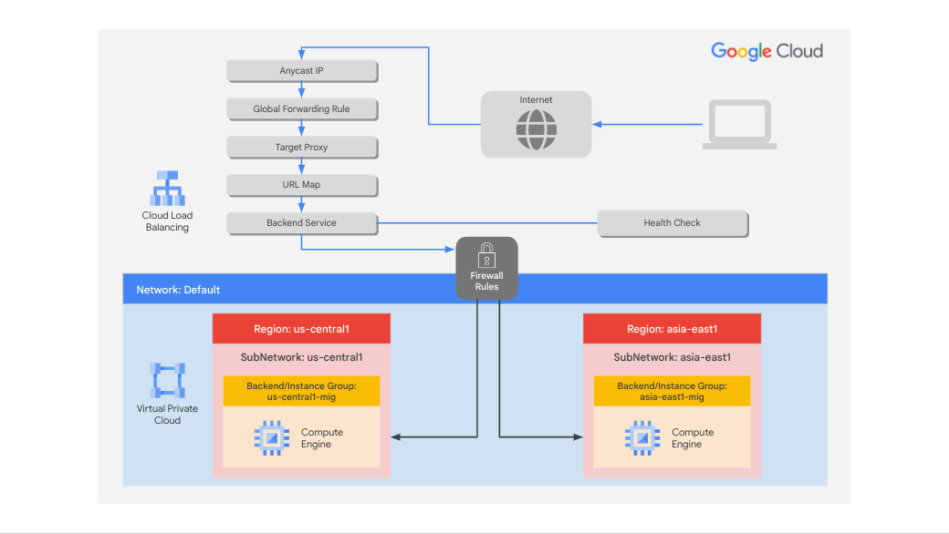

Start the configuration
- On the Navigation menu, click Network Services > Load balancing.
- Click Create Load Balancer.
- For Type of load balancer, select Application Load Balancer (HTTP/HTTPS), click Next.
- For Public facing or internal, select Public facing (external), click Next.
- For Global or single region deployment, select Best for global workloads, click Next.
- For Load balancer generation, select Global external Application Load Balancer, click Next.
- For Create load balance, click Configure.
- For Load Balancer Name, type http-lb.

Configure the frontend
The host and path rules determine how your traffic will be directed. For example, you could direct video traffic to one backend and direct static traffic to another backend. However, you are not configuring the host and path rules in this lab.
- Click Frontend configuration.
- Specify the following, and leave the remaining settings as their defaults:
Property | Value (type value or select option as specified)
Protocol | HTTP
IP version | IPv4
IP address | Ephemeral
Port | 80
- Click Done.
- Click Add Frontend IP and Port.
- Specify the following, and leave the remaining settings as their defaults:
Property | Value (type value or select option as specified)
Protocol | HTTP
IP version | IPv6
IP address | Auto-allocate
Port | 80
- Click Done.
Application Load Balancing (HTTP/HTTPS) supports both IPv4 and IPv6 addresses for client traffic. Client IPv6 requests are terminated at the global load balancing layer and then proxied over IPv4 to your backends.

Configure the backend
Backend services direct incoming traffic to one or more attached backends. Each backend is composed of an instance group and additional serving capacity metadata.
- Click Backend Configuration.
- Click Backend services & backend buckets > Create a Backend Service.
- Specify the following, and leave the remaining settings as their defaults:
Property | Value (select option as specified)
Name | http-backend
Backend type | Instance group
Instance group | us-1-mig
Port numbers | 80
Balancing mode | Rate
Maximum RPS | 50
Capacity | 100
Note: This configuration means that the load balancer attempts to keep each instance of us-1-mig at or below 50 requests per second (RPS).
- Click Done.
- Click Add Backend.
- Specify the following, and leave the remaining settings as their defaults:
Property | Value (select option as specified)
Instance group | notus-1-mig
Port numbers | 80
Balancing mode | Utilization
Maximum backend utilization | 80
Capacity | 100
Note: This configuration means that the load balancer attempts to keep each instance of notus-1-mig at or below 80% CPU utilization.
- Click Done.
- For Health Check, select http-health-check.
- Click check for the Enable logging checkbox.
- Specify Sample rate as 1.
- Click Create.
- Click OK.

Review and create the HTTP load balancer
- Click Review and finalize.
- Review the Backend services and Frontend.
- Click Create. Wait for the load balancer to be created.
- Click on the name of the load balancer (http-lb).
- Note the IPv4 and IPv6 addresses of the load balancer for the next task. They will be referred to as [LB_IP_v4] and [LB_IP_v6], respectively.
Note: The IPv6 address is the one in hexadecimal format.
Click Check my progress to verify the objective.
Configure the Application Load Balancer (HTTP)

Task 6. Stress test the Application Load Balancer (HTTP)
In this task, you stress test your Application Load Balancer (HTTP) to verify that traffic is forwarded to the backend service.
The Application Load Balancer (HTTP) should forward traffic to the region that is closest to you.
True
False

Access the Application Load Balancer (HTTP)
- In the Google Cloud console title bar, click Activate Cloud Shell ().
- If prompted, click Continue.
- To check the status of the load balancer, run the following command, replace [LB_IP_v4] with the IPv4 address of the load balancer:
LB_IP=[LB_IP_v4]
while [ -z "$RESULT" ] ;
do
echo "Waiting for Load Balancer";
sleep 5;
RESULT=$(curl -m1 -s $LB_IP | grep Apache);
done
Copied!
Note: Once the load balancer is ready, the command will exit.
- Open a new tab in your browser and navigate to http://[LB_IP_v4]. Make sure to replace [LB_IP_v4] with the IPv4 address of the load balancer.
Note: If you get a pop-up as EXTERNAL_IP doesn’t support a secure connection click Continue to site

Stress test the Application Load Balancer (HTTP)
Create a new VM to simulate a load on the Application Load Balancer (HTTP). Then determine whether traffic is balanced across both backends when the load is high.
- In the Cloud console, in the Navigation menu (), click Compute Engine > VM instances.
- Click Create instance.
- Specify the following, and leave the remaining settings as their defaults:
Property | Value (type value or select option as specified)
Name | stress-test
Region | A region different but closer to Region 1
Zone | A zone from the region
- For Series, select E2.
- For Machine type, select e2-micro (2 vCPU, 1 core, 1 GB memory).
Note: Because a region in US is closer to Region 1 than to notus-1, traffic should be forwarded only to us-1-mig (unless the load is too high).
- Click OS and storage, and then click Change.
- Click Custom Images.
- Click Custom Images, then for Source project for images make sure that qwiklabs project ID is selected.
- For Image, select mywebserver.
- Click Select.
- Click Create.
- Wait for the stress-test instance to be created.
- For stress-test, click SSH to launch a terminal and connect.
- If prompted allow SSH-in-browser to connect to VMs, click Authorize.
- To create an environment variable for your load balancer IP address, run the following command:
export LB_IP=<Enter your [LB_IP_v4] here>
Copied!
- Verify it with echo:
echo $LB_IP
Copied!
- To place a load on the load balancer, run the following command:
ab -n 500000 -c 1000 http://$LB_IP/
Copied!
Click Check my progress to verify the objective.
Stress test the Application Load Balancer (HTTP)
- In the Cloud console, in the Navigation menu (), click Network Services > Load balancing.
- Click http-lb.
- Click Monitoring.
- Monitor the Frontend Location (Total inbound traffic) between North America and the two backends for a couple of minutes.
Note: At first, traffic should just be directed to us-1-mig, but as the RPS increases, traffic is also directed to notus-1-mig. This demonstrates that by default traffic is forwarded to the closest backend, but if the load is very high, traffic can be distributed across the backends.
- In the Cloud console, in the Navigation menu (), click Compute Engine > Instance groups.
- Click on us-1-mig to open the instance group page.
- Click Monitoring to monitor the number of instances and LB capacity.
- Repeat the same for the notus-1-mig instance group.
Note: Depending on the load, you might see the backends scale to accommodate the load.

Task 7. Review
In this lab, you configured an Application Load Balancer (HTTP) with backends in Region 1 and Region 2. Then you stress-tested the Application Load Balancer with a VM to demonstrate global load balancing and autoscaling.

End your lab
When you have completed your lab, click End Lab. Google Skills removes the resources you’ve used and cleans the account for you.
You will be given an opportunity to rate the lab experience. Select the applicable number of stars, type a comment, and then click Submit.
The number of stars indicates the following:
- 1 star = Very dissatisfied
- 2 stars = Dissatisfied
- 3 stars = Neutral
- 4 stars = Satisfied
- 5 stars = Very satisfied
You can close the dialog box if you don't want to provide feedback.
For feedback, suggestions, or corrections, please use the Support tab.
Copyright 2026 Google LLC All rights reserved. Google and the Google logo are trademarks of Google LLC. All other company and product names may be trademarks of the respective companies with which they are associated.

